**PYTHON CODE**

|  |  |
| --- | --- |
| **TEAM ID:** | **PNT2022TMID00945** |
| **PROJECT NAME:** | **Gas leakage monitoring and alerting system** |

**CODE:**

**import random**

**print(&#39;Hazardous gas Level=&#39;,str(random.randint(0,100)))**

**print(&#39;Temperature=&#39;,str(random.randint(0,100)))**

**print(&#39;Humidity=&#39;,str(random.randint(0,100)))**

**print(&#39;Pressure=&#39;,str(random.randint(0,100)))**

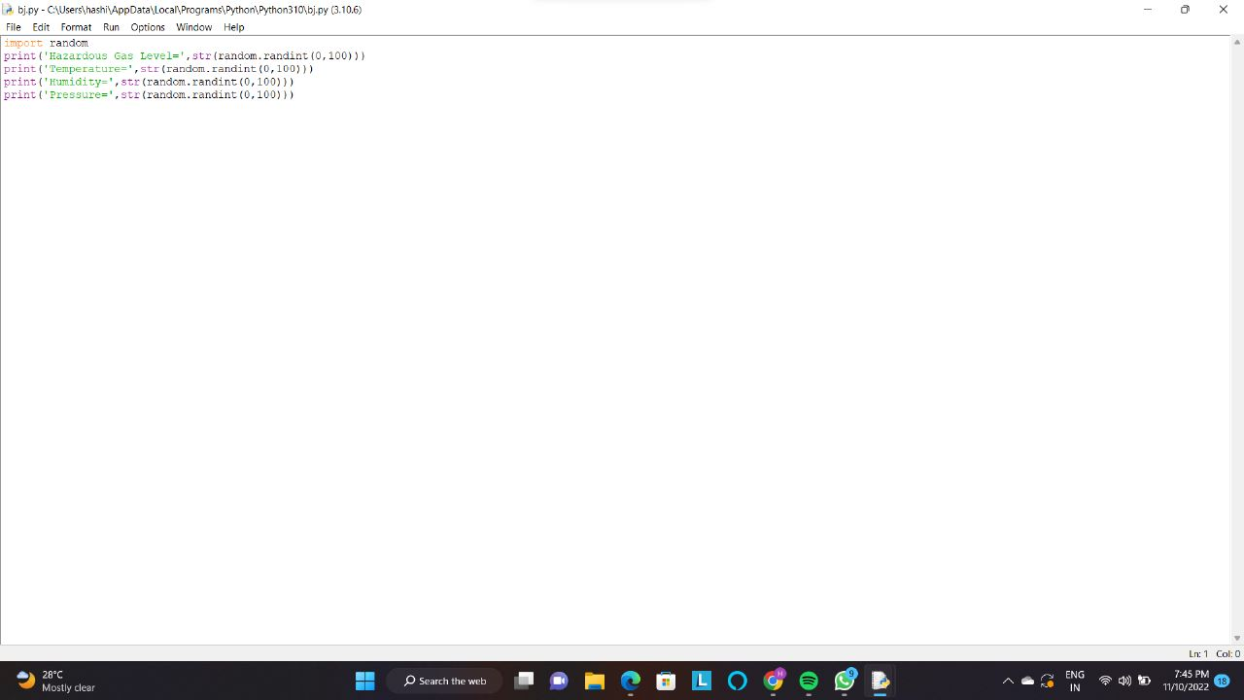

**OUTPUT:**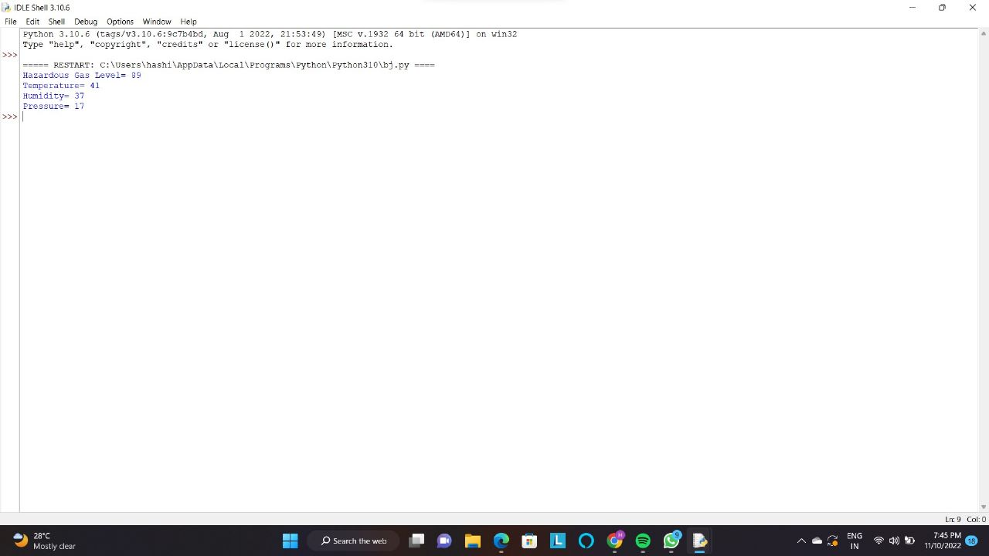

**WATSON CLOUD IBM:**

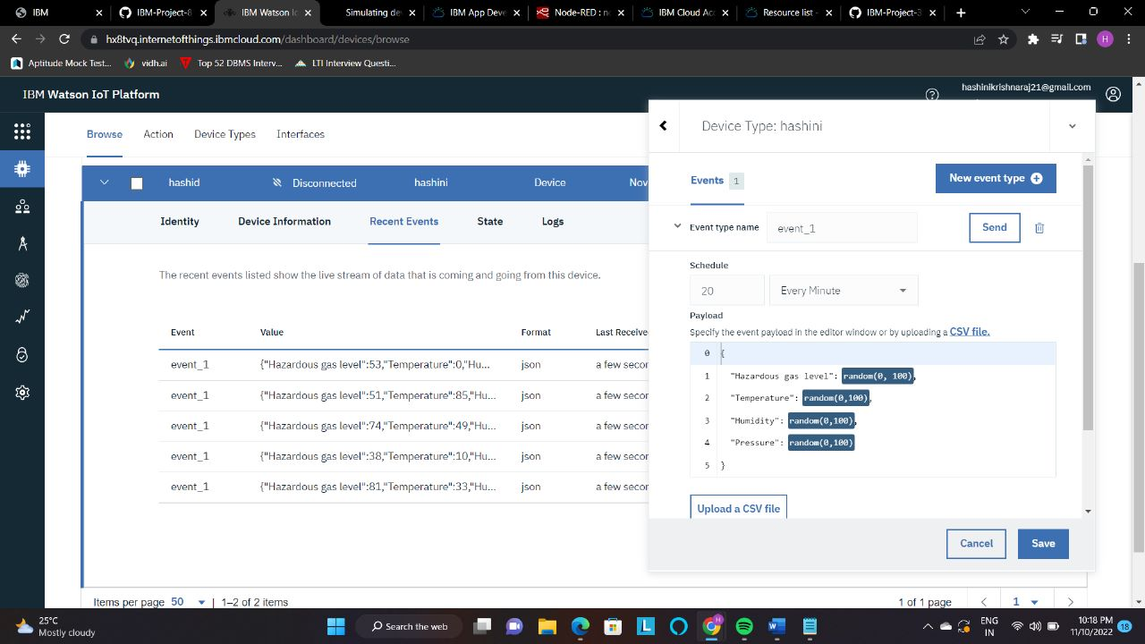

**Python code was developed successfully.**